**Whitewater Rafting Site Plan**

**Logo**

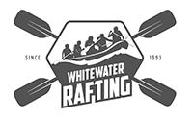

**Color Schema**

<https://coolors.co/6cbeed-ddca7d-535252-6d6d6d>

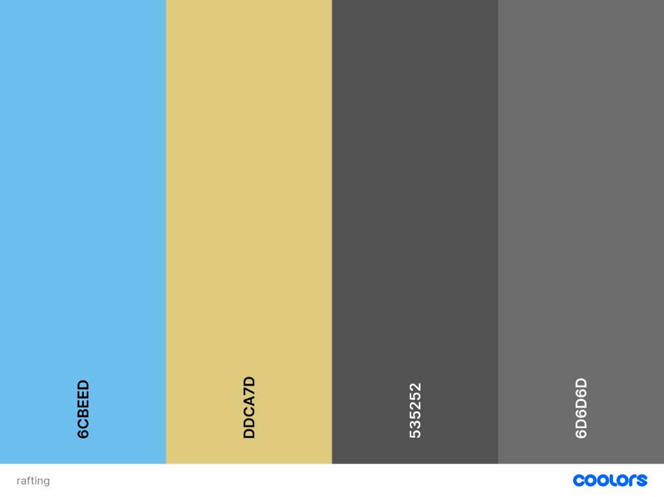

Primary color - #6CBEED

Secondary color - #DDCA7D

Accent 1 color - #535252

Accent 2 color - #6D6D6D

**Typography**

Heading font: Roboto Medium 500 and Bold 700

Text font: Montserrat 400 and 700